
EMMANUEL CHURCH AYLSHAM
Cawston Road, Aylsham NR11 6BX www.emmanuelaylsham.com
Treasurer: Diane Scott, 21 Hobart Lane, Aylsham NR11 6FA
Tel: 07747151903 scotts2@btinternet.com

CONDITIONS OF HIRE – 2025
- The hire charge for exclusive use of ground floor facilities is £15.00 per hour, please apply via our website, where you can see our availability on the Calendar.

- All hirers admitting the public or members are required to have their own Risk Assessment and Safeguarding Procedures in place for their event prior to the hire period. We do not hold any data about groups or their leaders except e-mail contact.

- Groups are given an access code for the front door, please do not share this beyond those who are responsible for the group. When using the code be sure to include the blue button when you enter to release the lock. When you leave press the blue button again to re-engage the lock, check the door is locked.

- On entering the building, please ensure the rear fire exit is unlocked and that access to the exits is not obstructed, these must be indicated to the group members.

- Your booking allows you 30 mins before and after your session to set up and clear the hall. We respectfully ask that you clean up after each session. Brushes and mops are available in the Chair store area and a rechargable vacuum cleaner is in the corner of the Café area.

- Fire Alarm – each user must have an Evacuation Plan for its own group should the alarm be activated. In the event of an accidental activation there is a checklist shown beside the front door control box to reset the system.

- A first aid kit is provided in the kitchen area

- Kitchen facilities are fully available, tea, coffee and milk are included in the hire. Please ensure you comply with food safety standards regarding food allergies for food served on the premises and take away any unused food or drink. We are not a licensed premises. Alcohol may be consumed on the premises in a responsible manner.

- The heating system is set on a timer so please do not interfere with the switches. When the heating is on, the display always shows the current room temperature, so if it is too warm open the doors and switch on fans (switch in the main hall grey cupboard) with tables.

- No posters or decorations are to be fixed to the windows doors or walls of the premises. Posters about groups can be displayed on the notice board at the bottom of the stairs.

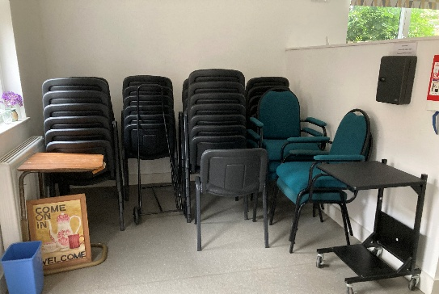
- The Changing Places toilet is a community resource available to those who need it at any time. Please be aware that people with disabilities and their carers may enter the building to use this facility during your session.

- Furniture is stored in a way to allow all groups the space they need, please return to the storage area beside the kitchen at the end of your session (see photo)

- We respectfully remind hirers that this is a church building, and as such request that you do not engage in activities contrary to Christian beliefs and values. If you are uncertain, please ask.

