**Afternoon Praise**

We meet at Emmanuel church together with friends for 1 hour.

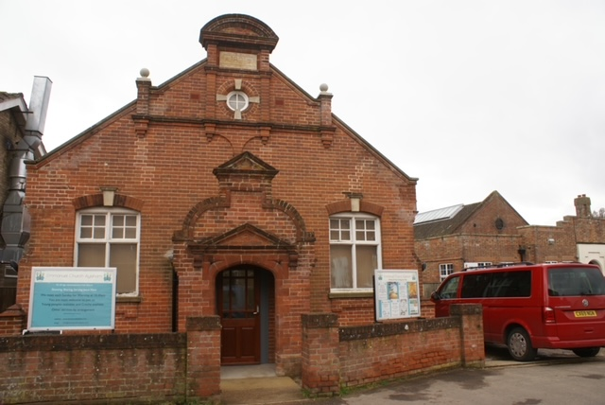

We will sit together and join in with singing, readings and making music.

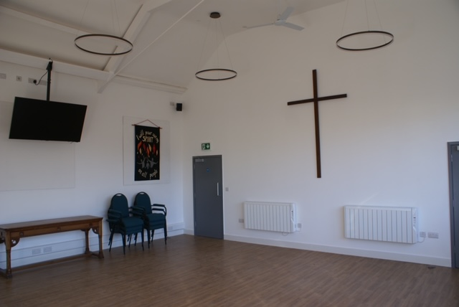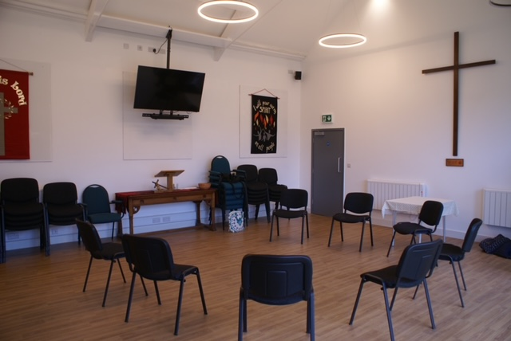

Afterwards, we will have food and drink together before we go home.

We might go through to the kitchen space for this.

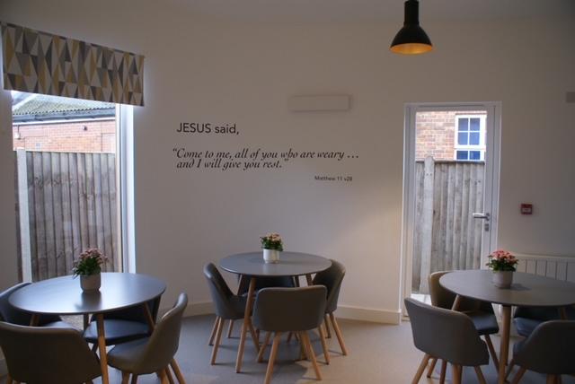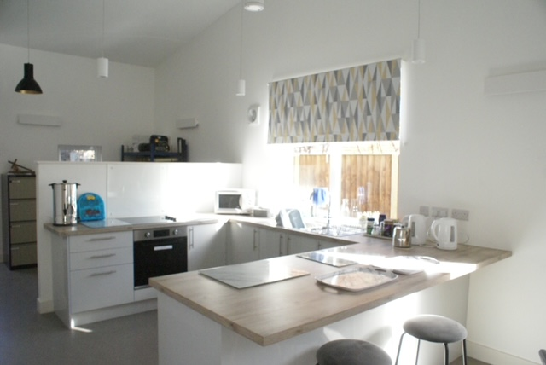

This is Brenda who will help with making our food and drinks.

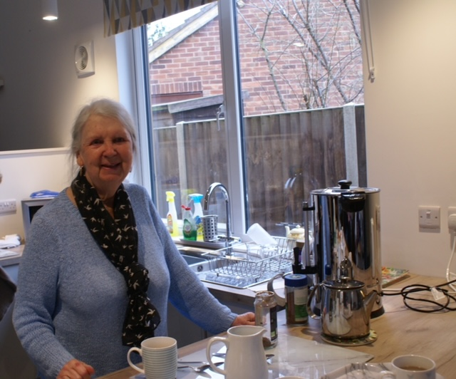

Inside the Church we have a Changing Places toilet and a standard toilet too.

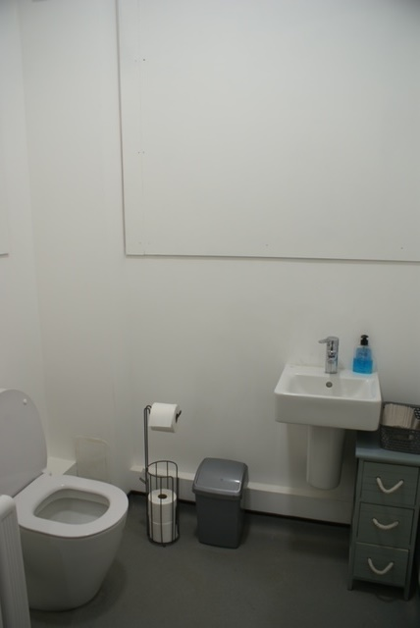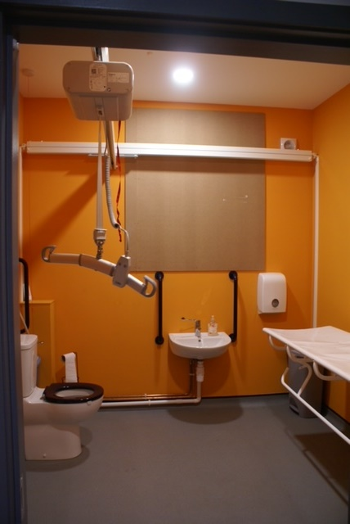

We are excited to see you!

